# 

**S4 Smart Surveillance System   
User manual   
[Version 1.0]**

Document History

|  |  |  |  |
| --- | --- | --- | --- |
| ***Version*** | |  |  |
| *Version* | *Date* | *Author* | *Description* |
| **V1.1** | 20-Aug-2024 |  | Initial version |
|  |  |  |  |

Distribution List

|  |  |  |  |
| --- | --- | --- | --- |
| ***Version*** |  |  |  |
| *Name* | *Position* | *Reviewer* | *Approver* |
|  |  |  |  |
|  |  |  |  |
|  |  |  |  |

**Confidentiality Notice:**

***This document, along with any attached files, is provided in confidence to the recipients listed above and is intended solely for evaluation purposes. Disclosure or sharing of this information with outside parties is prohibited without express written consent. If you are not the intended recipient, please refrain from using any part of this document and destroy it immediately, notifying the original sender of the action taken.***

Contents

Introduction 3

1. Patrolling Officer View 3

1.1 Login 3

1.2 Real-Time Monitoring 3

1.3 Alert Management 3

1.4 Communication 3

1.5 Post-Action Reporting 4

1.6 Log Out 4

2. Admin View 4

2.1 Dashboard 4

2.2 User Access Management 4

2.3 Manage Locations 5

2.4 Wallboard 5

Contact Support 5

# Introduction

Welcome to the Traffic Police Surveillance System. This manual provides a comprehensive guide for both Patrolling Officers and Admins on how to effectively use the system. Each section covers specific functionalities, processes, and includes placeholders for screenshots to help you navigate through the application.

# 1. Patrolling Officer View

## 1.1 Login

Steps:

1. Open the Traffic Police Surveillance System application on your mobile device.

2. Enter your provided credentials (username and password) into the login fields.

3. Click the “Login” button to access the dashboard.

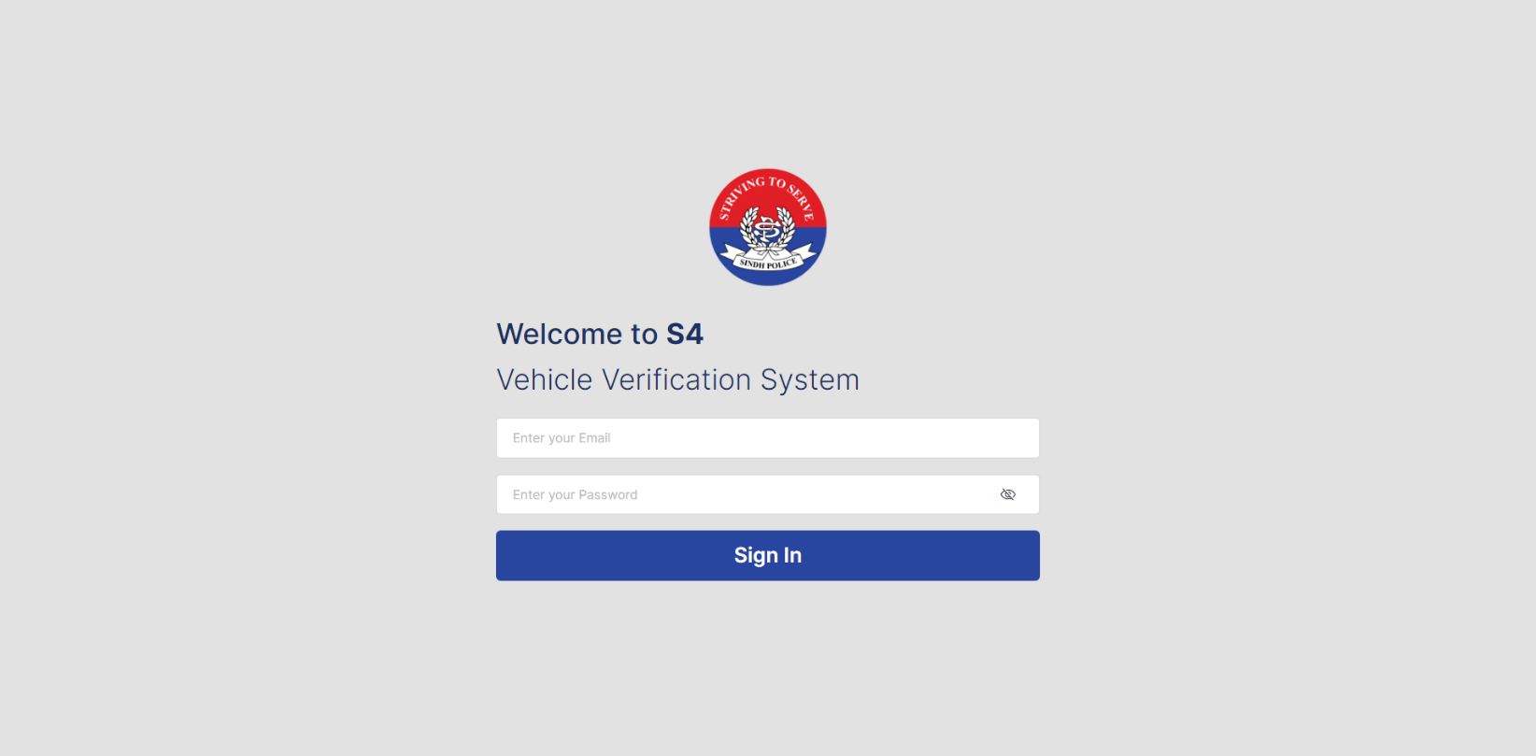

**Login Screen**

## 1.2 Real-Time Monitoring

Functionality:

1. As vehicles pass through the toll plaza, the system captures their license plate images.

2. These images are sent to the Camera Server for license plate number extraction and verification against the AVLC, Excise, and CRO databases.

3. Monitor the live feed of vehicles and view details of the vehicles under surveillance.

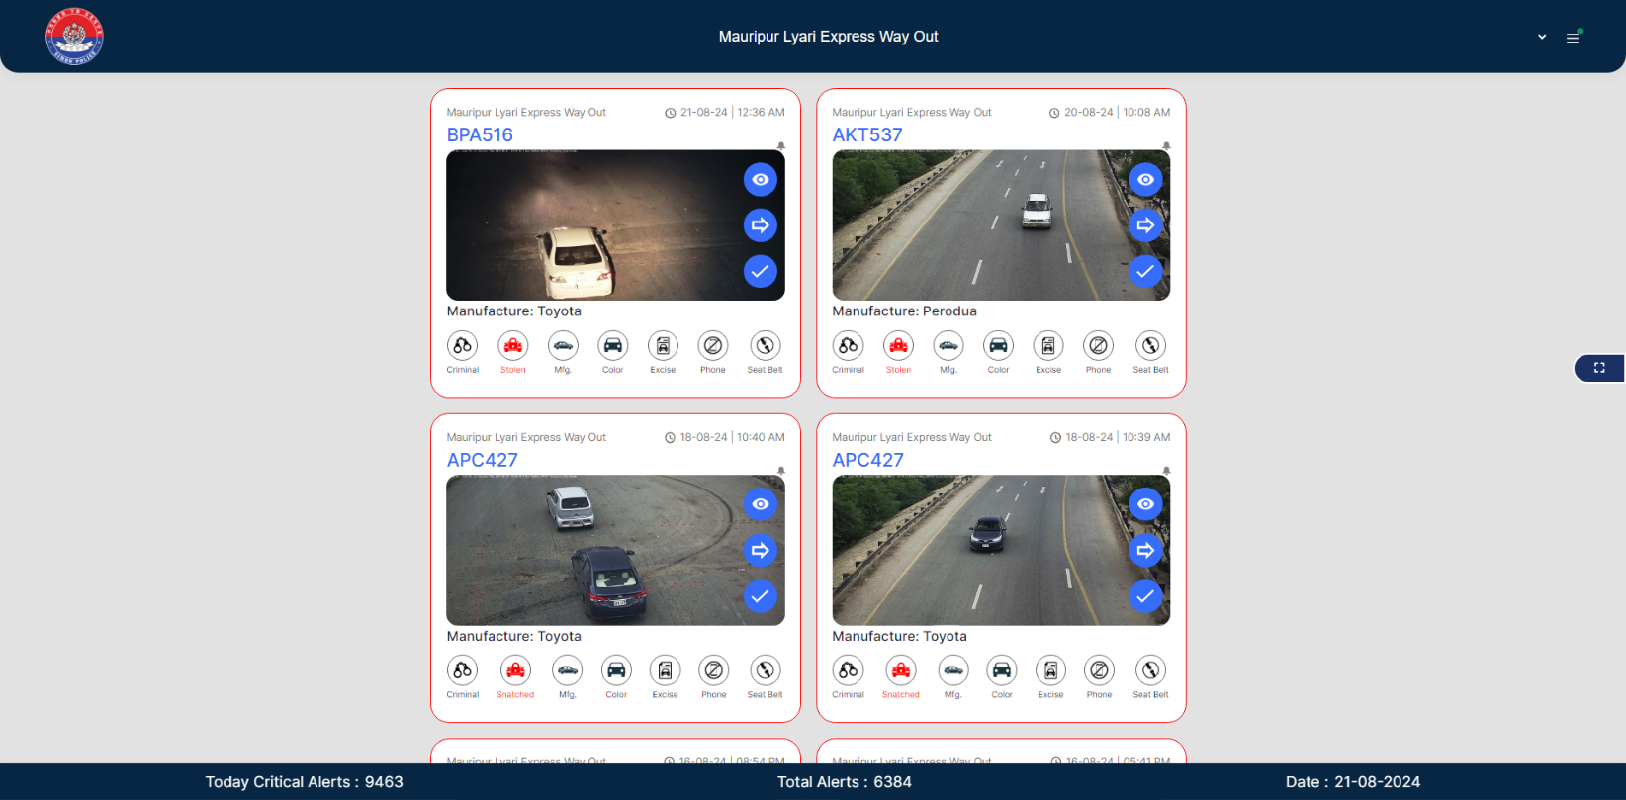

**Live Feed Screen**

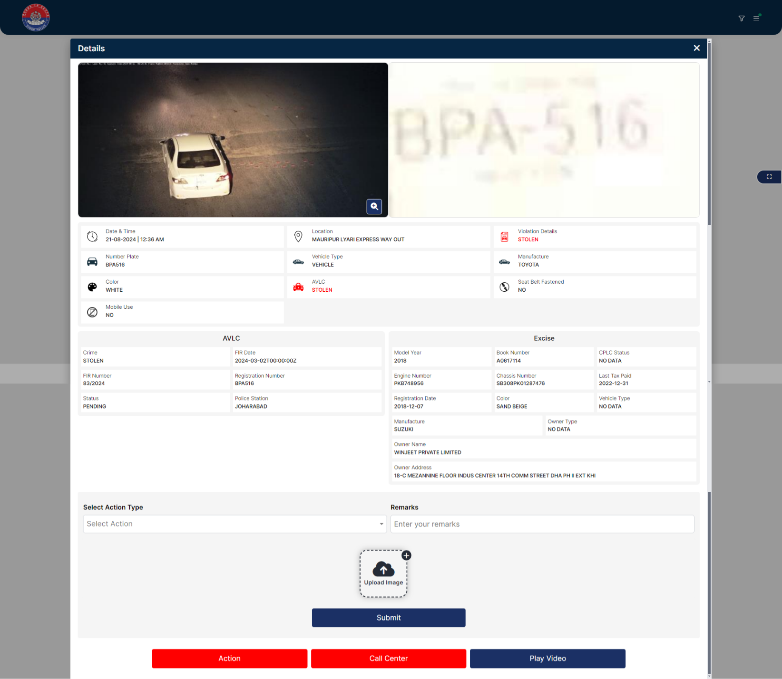

**Vehicle Details Screen**

## 1.3 Alert Management

Functionality:

1. If a vehicle is flagged for violations, an alert is generated and pushed to your device.

2. The alert includes:

- Vehicle’s license plate number

- Nature of the violation

- Relevant database (AVLC, CRO, Excise)

Steps:

1. Review the alert details on your device.

2. Determine the appropriate action (e.g., pulling over the vehicle).

3. Acknowledge the alert to indicate that the situation is being handled.

Screenshot Placeholders:

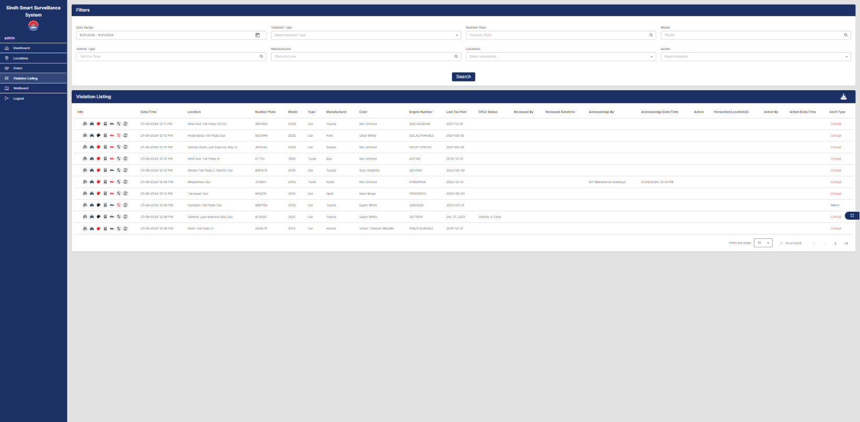

**Alert Details Screen**

## 1.4 Communication

Functionality:

1. Use the integrated AVAYA system to communicate with other officers or the central control room.

2. All communications are logged within the system.

Steps:

1. Access the AVAYA system from your dashboard.

2. Initiate a conversation with the required parties.

## 1.5 Post-Action Reporting

Functionality:

1. Submit a report detailing actions taken and outcomes after handling an alert.

2. The report is stored in the database, associated with the specific alert and vehicle.

Steps:

1. Navigate to the reporting section of the application.

2. Fill out the required fields and submit the report.



**Post-Action Reporting Screen  
  
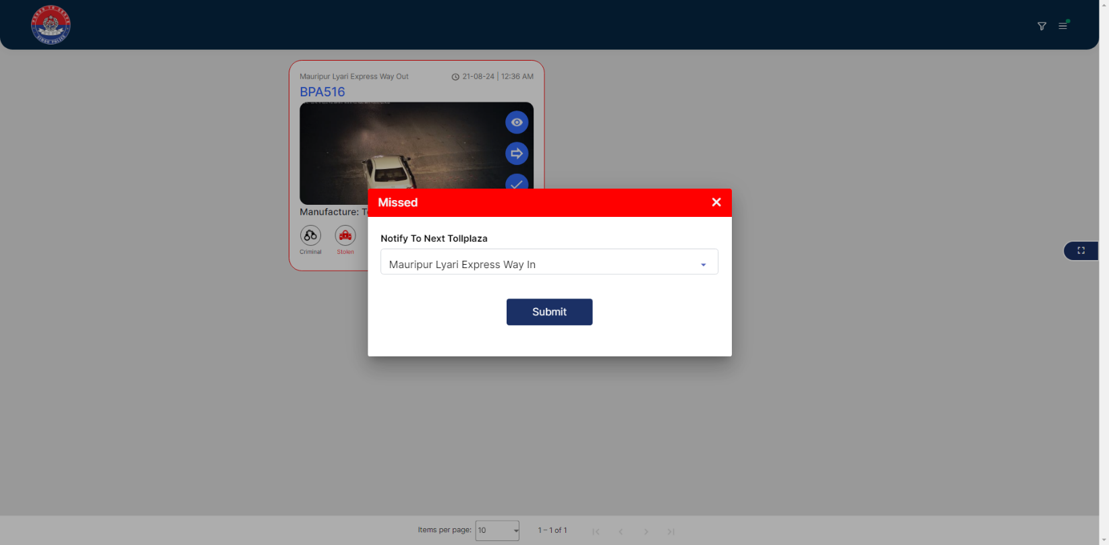**

## 1.6 Log Out

Steps:

1. Click on the “Logout” button on the dashboard.

2. Ensure that all activities are securely logged and the session is terminated.



**Logout Screen**

# 2. Admin View

## 2.1 Dashboard

Functionality:

1. Provides an overview of violations by date and location.

2. Displays daily and monthly statistics, and allows for custom date range queries.

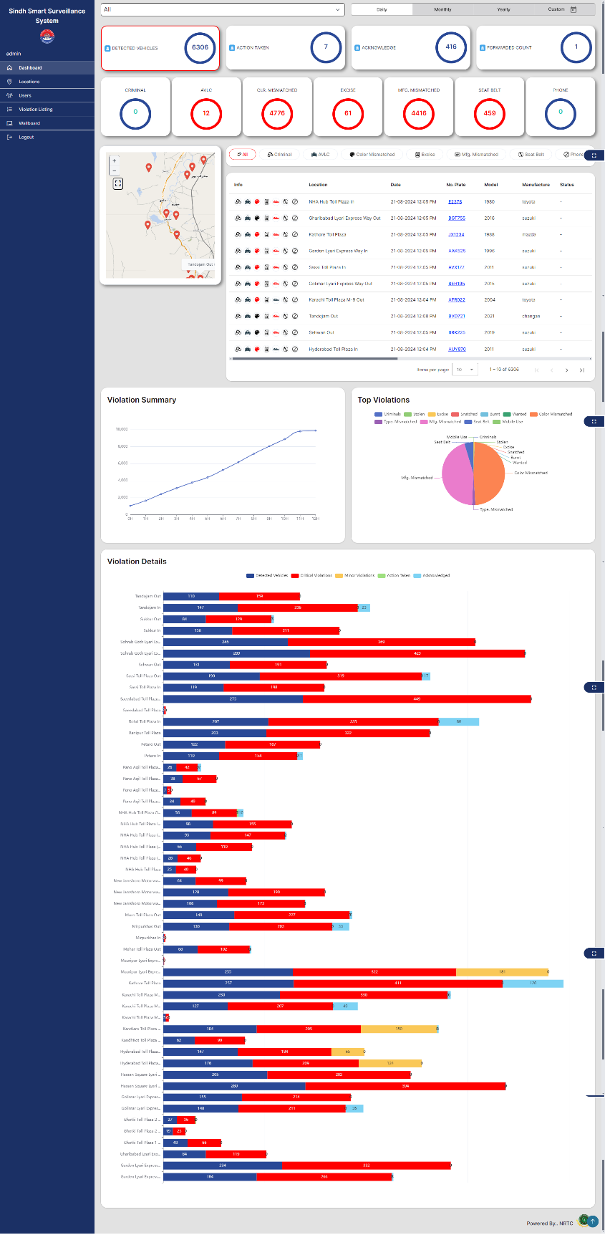

**Dashboard Overview Screen  
  
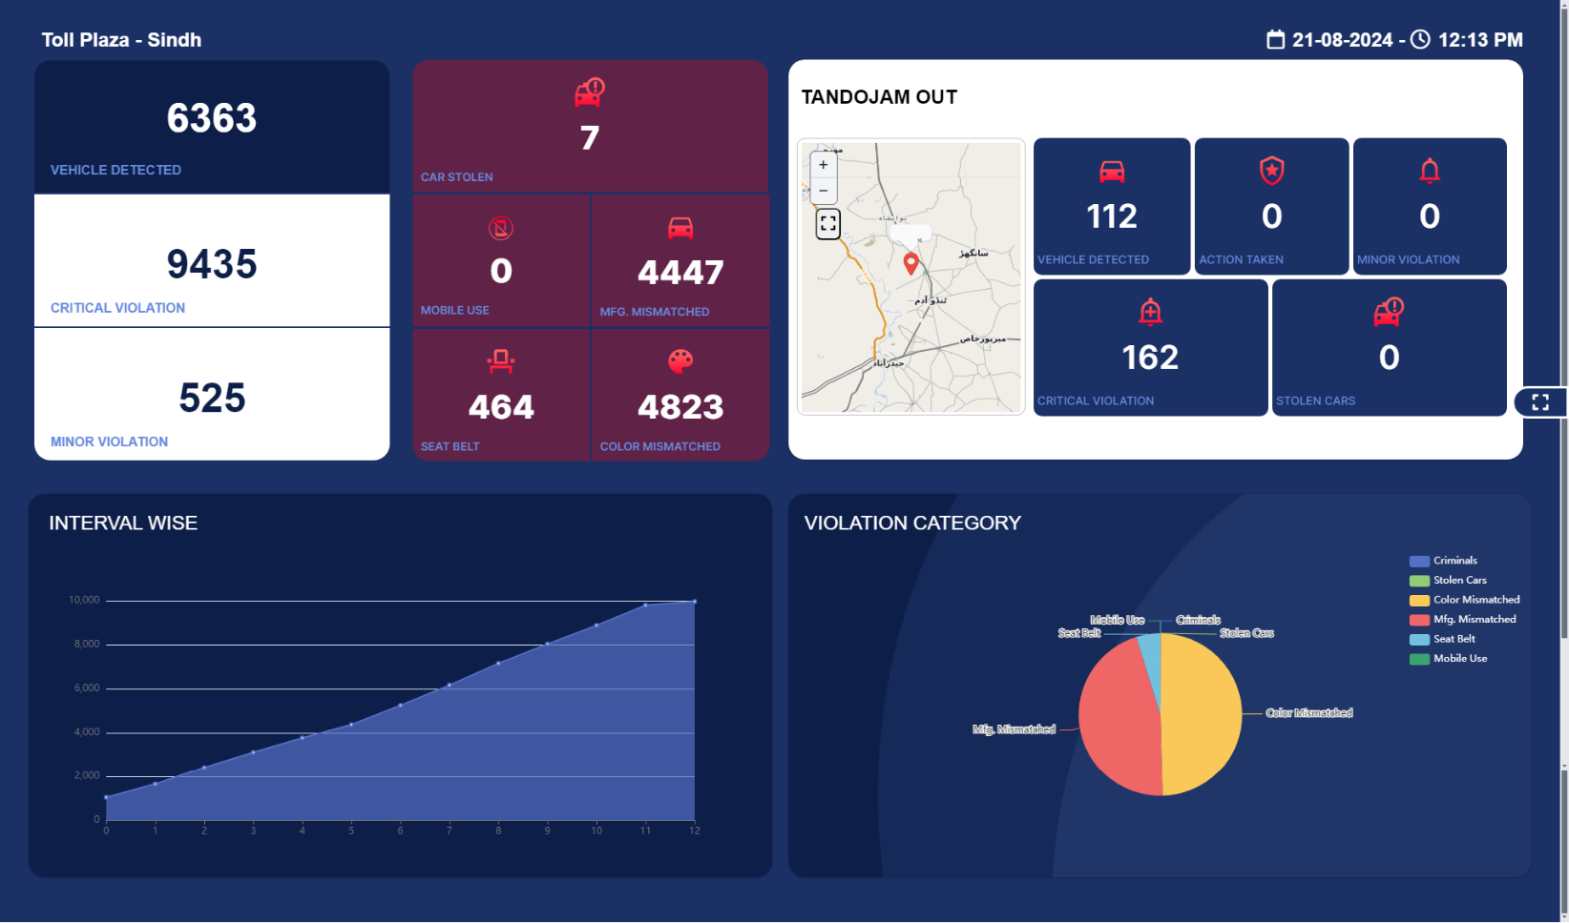**

**Daily Statistics Screen**

## 2.2 User Access Management

Functionality:

1. Manages user roles and access levels.

Roles:

1. Super Admin

Highest level of control.

Can create and manage admin accounts.

Full access to all locations and data.

Configures system settings and manages security.

2. Patrolling Officer

Receives real-time notifications for assigned locations.

Can submit actions and view individual alert details.

Can browse old notifications and change their account password.

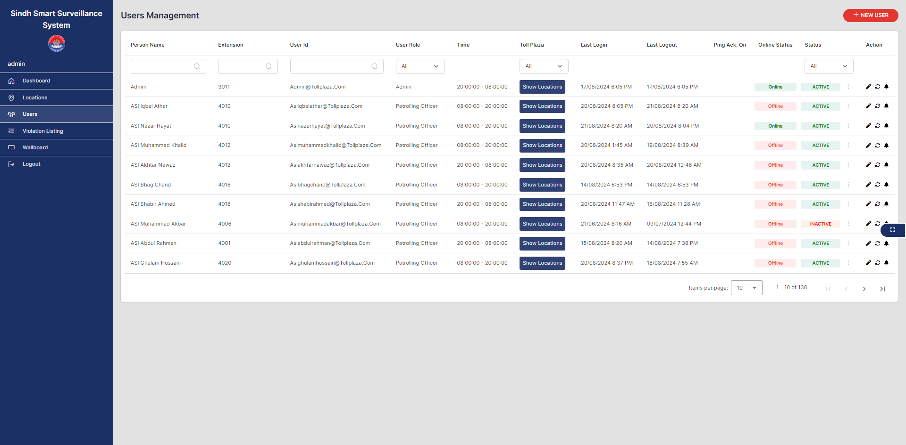

**User Access Management Screen**

**Role Assignment Screen**

## 2.3 Manage Locations

Functionality:

1. Add and modify locations within the system.

Steps:

1. Navigate to the “Manage Locations” section.

2. Add or update location details as required.

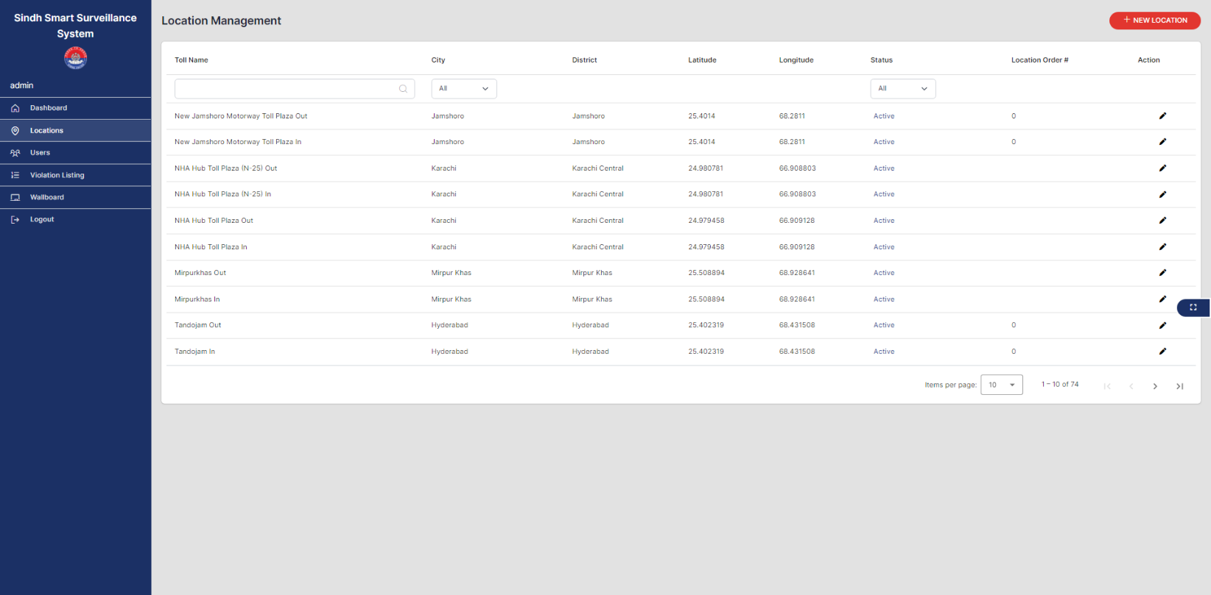

**Manage Locations Screen**

## 2.4 Wallboard

Functionality:

1. Provides a real-time visual display of key statistics based on location.

2. Shows metrics such as alerts generated, types of violations, and actions taken.

3. Customizable to focus on specific metrics or locations.

**  
  
Wallboard Overview Screen**

**Location-Based Statistics Screen**

**Real-Time Updates Screen**

## Contact Support

For any issues or further assistance, please contact the system administrator or technical support team.